
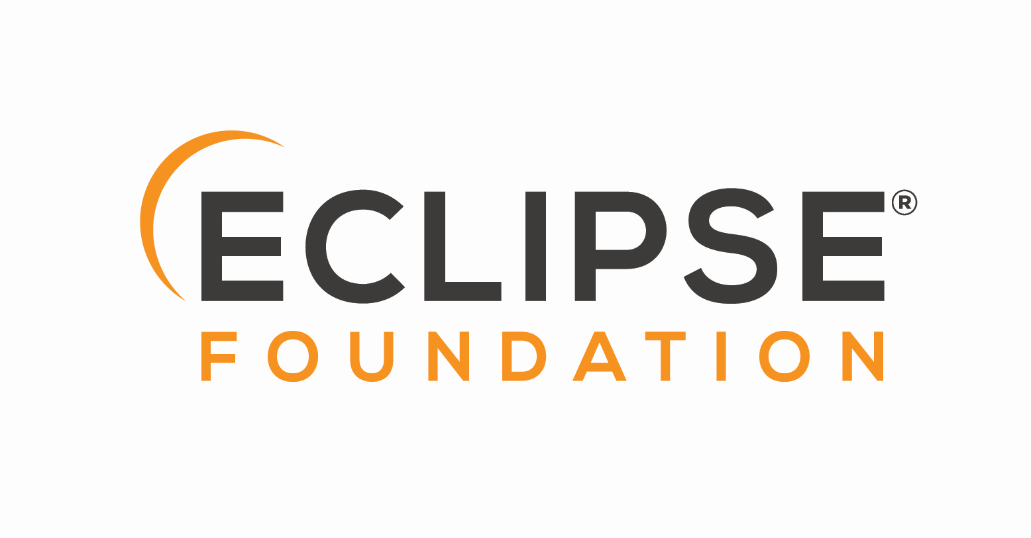

Adoptium
Project Management Committee
Agenda & Minutes

“The PMC as a whole, and the PMC leads in particular, are ultimately responsible for ensuring that the Eclipse Development Process is understood and followed by their Projects. The PMC is additionally responsible for maintaining the Top-Level Project’s charter.” [ref]

Date: 2026-July-22

Agenda:
- Approval of minutes from the July 15, 2026 meeting.
- Review of outstanding actions.
- Review of GitHub issues and discussions flagged for PMC agenda
- July release update
- Review of activity reports in adoptium repo
- AoB

Action items:
Date | Description | Status
None

Attendees
George Adams
Stewart Addison
Scott Fryer
Severin Gehwolf
Shelley Lambert
Andrew Leonard
San Hong Li
John Oliver
Martijn Verburg
Tim Ellison

Minutes:

This meeting was skipped.

